Official CKC Premium List
MASTER, SENIOR & JUNIOR HUNT TESTS

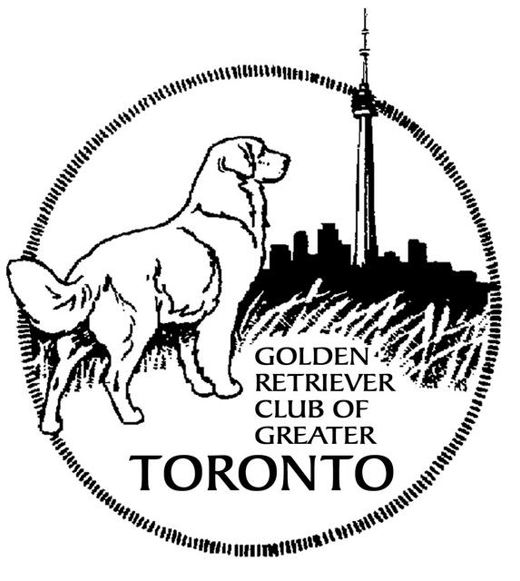

Saturday September 6, 2014
Sunday September 7, 2014

Headquartered at Companion Dog Training
6926 /6924 Concession 2,
Puslinch Township
No E-collar use on HQ property or any test sites please.

Saturday Sunday
Master Hunter 8:00a.m.
Junior/Senior Hunter 9:00 a.m.

Open to all Retrievers, Irish Water Spaniels and Standard Poodles
These events are held under the rules of the Canadian Kennel Club

Entries close Tuesday September 2nd, 2014 at 8:00 p.m.
GRCGT is a member of the Canadian National Master Hunt Test Club.
Visit http://www.canadiannationalmaster.com/ for details

Important: The Non-Member Participation Fee applies to dogs wholly owned by a resident of Canada who is not a member of the CKC; it is not applicable to CKC members or dogs co-owned with a CKC member. In order for the title to be awarded, the non-member will have a choice to either become a CKC member or pay the Non-Member Participation Fee. Failure to comply within 30 days of notification will result in the title being withheld and the dog cannot be moved up to the next level. (For a Membership application, please go to www.ckc.ca under CKC Services and Forms On-Line). The Non-Member Participation Fee is fee paid in the calendar year (January – December) in which the dog achieved its title and/or titles. If you have any questions or concerns, please contact CKC Head Office
TEST COMMITTEE GRCGT EXECUTIVE
Chair: Tim Marshall President: Gordon Kerr
Secretary: Shelly Blom Vice-President: Nancy Fieder
Secretary: Sandra Brodie
Treasurer: Norm Bowler
Directors: Sheila Phillips
Shelly Blom
Deb Grech

CKC Officers
Director (Events and Operations): Elio Furlan, 200-89 Ronson Drive, Suite 400., Etobicoke, ON M9W 5Z9 416 -675-5511
Zone Dir.: Alan Ewles afkingsalukis@hotmail.com
Retriever Hunt Test Council Chair.: Doug Windsor butterblac@golden.net

Your Judges
Saturday September 6, 2014 |  | Sunday September 7, 2014
Laureen Kinney, Ottawa ON  Gail Bourgeois, Oakville ON | Master | Deb Rusaw, Apsley ON  Lola Nichol, Windham Centre ON
Deb Rusaw, Apsley ON  Lola Nichol, Windham Centre ON | Senior | Laureen Kinney, Ottawa, ON  Gail Bourgeois, Oakville ON
Deb Rusaw, Apsley ON  John Chevalier, Cavan ON | Junior | Laureen Kinney, Ottawa ON  John Chevalier, Cavan ON

*Please note that there shall be a combined limited entry of 25 dogs in Senior and Junior each day*

Please check in with the Test Secretary upon your arrival to the Test Headquarters
- Please check in with the Marshall upon arrival at your stake. It is the responsibility of the handler to inform the marshall if they have dogs running in other stakes, and the marshall has the authority to move dogs for the efficiency of the test.
- Game birds will be used.
- Shotguns may not necessarily be used. However, handlers may be required to handle a gun or replica during the test. Gun Safety is considered as part of the test.
- All handlers MUST wear dark or camouflage clothing.
- Handlers are expected to be familiar with the CKC Rules and Regulations for Hunt Tests.

ENTRY FEES (HST inc)

JH $50.00
SH $55.00
MH $60.00

SEPARATE entry forms MUST be completed for EACH dog for EACH days test.
Please use the official CKC Hunt Test Entry form:
http://www.ckc.ca/CanadianKennelClub/files/6a/6a933234-0425-413f-b0a2-6c922237a2ff.pdf

LISTING FEE: The $9.30 listing fee (HST inc.) must be submitted for any dog
without an individual CKC registration number or ERN number.

PAYMENT: Payment may be made by Cheque or Cash at the time of entry. Post-dated cheques will not be accepted. Makes cheques payable to: Golden Retriever Club of Greater Toronto

N.S.F. CHEQUES: There will be a $20.00 charge for N.S.F. cheques.
Cheques will not be accepted the weekend of the Tests.

Forward cheques and entry forms to:

Shelly Blom, 39 June Ave, Guelph ON N1H 1H5

Contact sterregoldens@sympatico.ca or 519-589-6680 before 9:30pm for information. Email inquiries preferred as the secretary will be at a field trial the weekend before closing. Secretary will not be able to return phone calls to USA exhibitors during this time. Entries by regular mail, drop-off, or courier only please. Send courier entries no signature required as secretary will not travel to post office for pickup. Individual confirmations will not be mailed. Running order will be determined by a random draw.conducted at the home of the secretary after closing. The running order will be posted on the club website after the draw. Please check there to confirm receipt of entry. http://www.grcgt.org

No entries will be accepted after the closing date.

REFUNDS will be given for Bitches in season. A Veterinarian Certificate must be submitted before the start of the test.

Excerpt from CKC Rules & Regulation for Hunt Tests
Chap.18: Sec.7: “It shall be the duty and obligation of the event giving club to see that a judge, club official, volunteer, or any participant at a hunt test held under these regulations, is not subjected to indignities of any kind. The Hunt Test Committee Chair shall promptly report to the Canadian Kennel Club any infringement of this regulation, and the Discipline Committee shall have the authority to take such action as it deems fit on receipt of a report indicating this has occurred.”

MEALS
Lunch will be available for purchase at Headquarters. Fast food and grocery stores are available a short drive from headquarters in the south end of Guelph.

Ribbons will be presented at the conclusion of each stake.

ACCOMMODATIONS:
Hotel/Motel
Days Inn, 785 Gordon St., Guelph, 519-822-9112 http://www.daysinnguelph.ca/index.html

Comfort Inn, 480 Silvercreek Parkway, Guelph On 519-763-1900

Parkview Motel, 721 Woolich St, Guelph OH 519-836-1410
http://www.parkviewmotel.ca

*Provided for your information only. Please inquire directly with these hotels as to their pet policy.*

Camping
Valens Conservation Area Regional Road 97, Flamborough ON
905-659-7715 to reserve

Guelph Lake Conservation Area Twp Rd 6, Guelph ON
519-824-5061

VETERINARY SERVICES:
Emergency Veterinary Clinic of Waterloo Region 405 Maple Grove Rd, Unit 14, Cambridge ON
519-650-1617

Campus Estates Animal Hospital 1460 Gordon St South, Guelph ON
519-837-1212

HEADQUARTERS
Please drive slowly up the driveway. Children and dogs play here. There is a large blue sign that says Companion Dog Training at the bottom of the driveway.
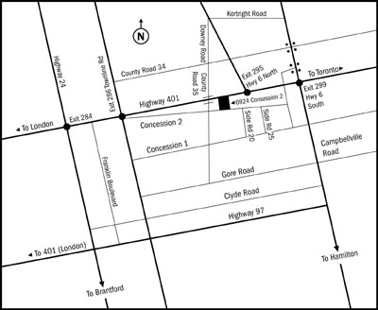
From Toronto:
Take the 401 West to Hwy 6 North (the second Hwy 6 exit). At the first set of lights turn left (Wellington Rd 34). Follow this road to County Rd 35 and turn left using he roundabout. You will cross the 401. Turn left on to the first road - Concession 2 - there is a sign for Paddock Corners. Turn left into the first driveway
From London:
Take the 401 east to Townline Rd (exit 286). Once you come off the 401, turn right at the lights and then left at the next set of lights. You will be on Lake Rd. Follow this road until you come to a stop sign. Keep right at the stop sign and the road turns into Concession 2. You will come to another stop sign (county Rd 35). Go straight through the stop sign and turn left into the first driveway.
From the North:
Take the Hanlon Expressway (Hwy6) south to Downey Rd (the YMCA is on the corner). Turn right and follow this road out of Guelph and into the country. Cross the 401, turn left at the first road (Concession 2). There is a sign for Paddock Corners. Turn left into the first driveway.
From the South:
Take Hwy 6 towards Guelph. Look for the sign for Leslie Road and turn left (if you go into the little town of Morriston, you missed it). Follow this road to Side Road 20 and turn right. Sideroad 20 dead ends at Concession 2. Turn left.

